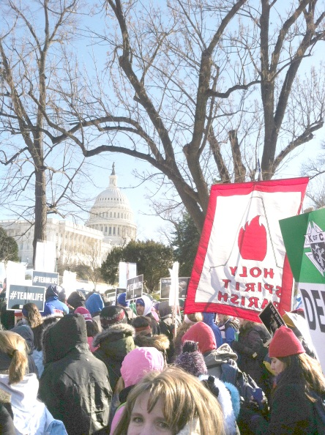
March for LIFE!
Friday, January 22, 2015
9a.m.-4:30p.m. (maybe later – see below)
The bus will be available on a first come first serve basis, so get this form in ASAP! Please return this form, with payment, no later than Tuesday, January 19th.

The parish will be attending the annual March for Life in DC again this year with busses departing from Holy Spirit! Let’s fill a whole bus with youth! All registered Middle School youth members in 8th grade are invited to attend under the supervision of the youth office. (It isn’t too late to register for the youth group!) We will begin the day with breakfast so read below for the complete details and send your form to the youth office today!

All 6th and 7th graders, are encouraged to attend the march with their families. Please contact cbrilhart@holyspiritchurch.us or call the rectory office at 703-978-8074 to sign up. We are all together on the busses and at the march – we all follow the red and white Holy Spirit flag!!

Below is our schedule for the day and what you need to bring.

Schedule:
9:00a.m. We will meet in the school cafeteria for a hot breakfast and poster making. Cost: $5 for Breakfast. (This is for the 8th graders only)
10:15a.m. There will be a special Mass just for the Pro-Life cause in the church. We will sit together and pray for an end to abortion! (Father has given us a special dispensation to eat before the Mass)
10:45a.m. We will board the bus and head to the National Mall for the March!
4:30p.m. We plan to be back by 4:30p.m. but please note that this all depends on traffic. We could be a little later. I will have the youth call/text you when we are on our way back! They are permitted to carry cell phones on this event.
What to Bring:
- Appropriate Clothing: We will be outside for the entire march and this event goes on rain, snow or shine. Please be sure to check the weather the night before and dress accordingly. Warm coats, hats, gloves and good walking shoes are a must. The ground will be muddy. Bring a small back pack and pack an umbrella/rain jacket/poncho in case of rain or snow, hand warmers etc.
- Bagged Lunch and snacks: We will be providing breakfast but please bring a lunch, snacks and water for the rest of the day.
-------------------------------------------------------------------------------------------------------------------------------
(Please turn this bottom half and the $5 in NLT January 19th)
€ Yes, my youth has permission the attend The March for Life event as described above.
€ Yes, I have a Holy Spirit Registration Form on file. If not, please go to our website www.holyspiritchurch.us to download a form or e-mail : msyouthministry
€ Yes, I can be a chaperone for this event!

Parent’s Signature:___________________________________ Date:_____________________
Youth’s Name: _________________________________________________________________
Best Phone number to reach a parent at during this event: _____________________________

