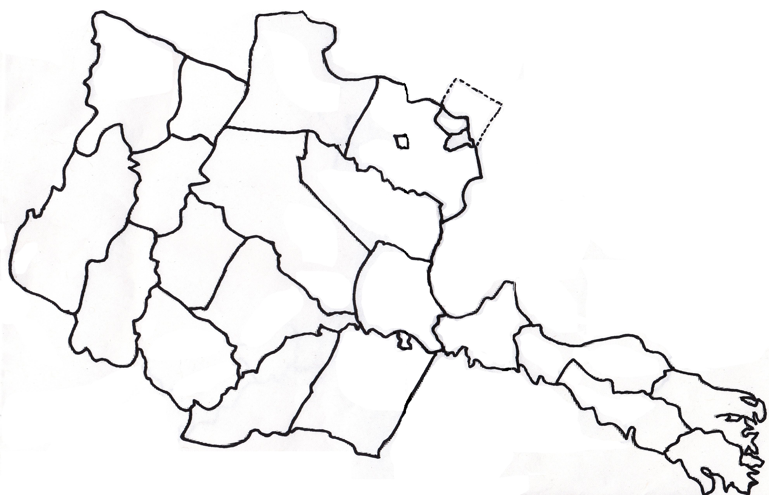

**Project St. Lucy**

**Distributing Food Throughout the Diocese of Arlington**

**Arlington County**

**Arlington County**

**Orange County**

**Spotsylvania County**

**Westmoreland County**

**Northumberland**

**County**

**Richmond County**

**Lancaster County**

**H:\CHOW and Food Assistance Info\CHOW Van.pngH:\CHOW and Food Assistance Info\CHOW Van.pngH:\CHOW and Food Assistance Info\CHOW Van.png**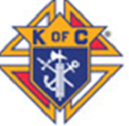

**Lancaster County**

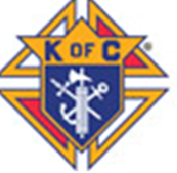

**King George**

**County**

**Richmond County**



**Orange County** 

**Westmoreland County**



 **Rappahannock**

**County**

**Fairfax County**

**Prince William County**



**Frederick County**

**Fauquier County**

**Warren County**

**Clarke County**



**Shenandoah County**

 Project St. Lucy - CHOW Hub

CHOW Depots

Diocese of Arlington Parishes

Lead Food Pantries Supported by CHOW

**Loudoun County**



**Spotsylvania County**

**Culpeper County** 



**Madison County**



**Page County**

**Alexandria City**

**Northumberland**

**County**

**Stafford County**

**Orange County**

**Fairfax City**

**Arlington County**