Holy Spirit High School Youth Ministry
Old Rag Hike and Mass
Monday, October 14, 2019 6:45a.m.-5p.m.
(Please register online by Friday, October 11)

Join us for this beautiful hike in the Shenandoah with Fr. O'Donohue. With steep trail switch backs, HUGE boulders to scramble and a 360 degree view of the Sehanandoah Valley, this is not a hike to miss! Father O'Donohue always finds us a gorgeous lookout for Mass and lunch and depending on time we may stop for a treat on the way back. Come and bring a friend! CHAPERONES ARE NEEDED TO HIKE AND DRIVE!

When: Monday, October 14, 6:45a.m.-5p.m.
Where: We will depart from and return to the Holy Spirit Parking lot (in front of the school building). Transportation will be provided.
What to bring: $5 for parking/food on the way back, bagged lunch, snacks for the trail, plenty of water and appropriate clothing for the hike: good hiking shoes, a string bag to hold food and any layers you may want to put on or take off. Check the weather before you leave the house

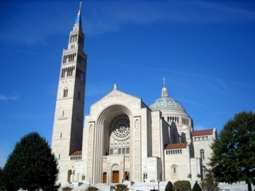
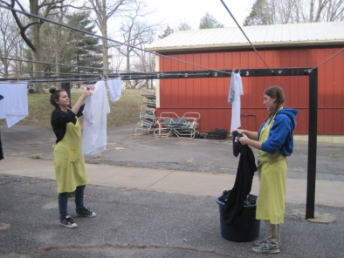
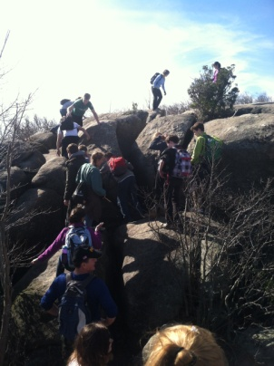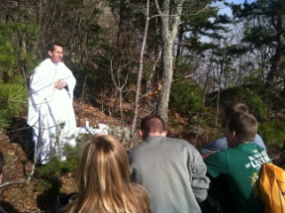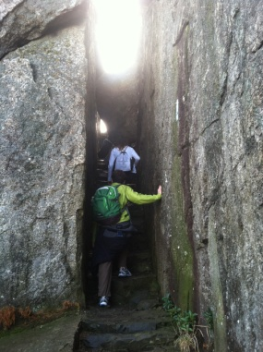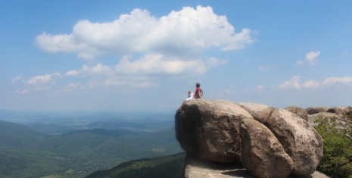

Sign-Up online @ holyspiritchurch.us/youth/high-school/

Questoins? E-mail Leslie McClellan at youthministry@holyspiritchurch.us.
For this outing, you may reach Leslie on her Cell Phone at (228) 327- 4039.

