Holy Spirit High School Youth Ministry
Old Rag Hike and Mass
Monday, October 12, 2015 7a.m.-4p.m.
(Please turn this form & payment in to Youth Office by Wednesday, October 7)

Join us for this beautiful hike in the Shenandoah with Fr. O'Donohue on Columbus Day. With steep trail switch backs, HUGE boulders to scramble and a 360 degree view of the Sehanandoah Valley, this is not a hike to miss! Father O'Donohue always finds us a gorgeous lookout for Mass and lunch. Come and bring a friend!

When: Saturday, October 12, 6:45a.m.-4p.m.
Where: We will depart from and return to the Holy Spirit Parking lot (in front of the school building). Transportation will be provided.
What to bring: Bagged lunch, snacks for the trail, plenty of water and appropriate clothing for the hike: good hiking shoes, a string bag to hold food and any layers you may want to put on or take off. Check the weather before you leave the house!
Cost: $5

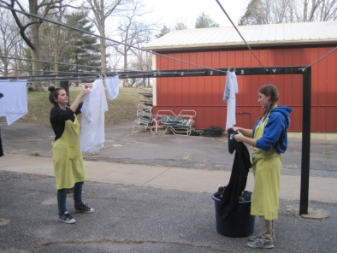
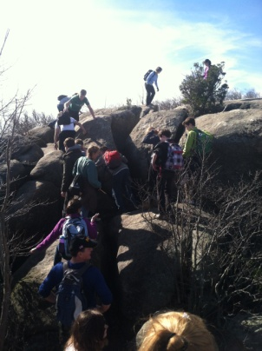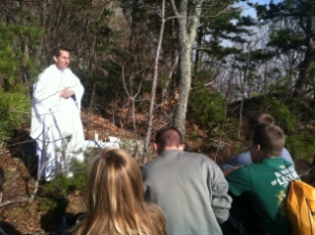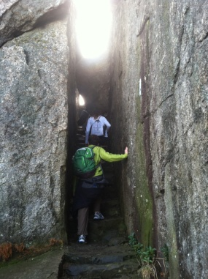

Questions? E-mail Kate Kelly at youthministry@holyspiritchurch.us.
For this outing, you may reach Kate on her Cell Phone at (703) 268 0460.

-------------------------------------------------------------------------------------------------------------------------------
Cut here – save top portion for your information.

____ Yes! My teen(s) ______________________________________________________ has my permission to attend the Old Rag Hike and Mass Outing as described above.
____ I would love to help drive/chaperone this hike (we need drivers)!
____ I have a Holy Spirit Registration form on file in the Youth office.
If not, please go to www.holyspiritchurch.us/youth and fill one out!

Parent’s Signature:____________________________________________________________
Best Phone to use during this event:_____________________________________________

