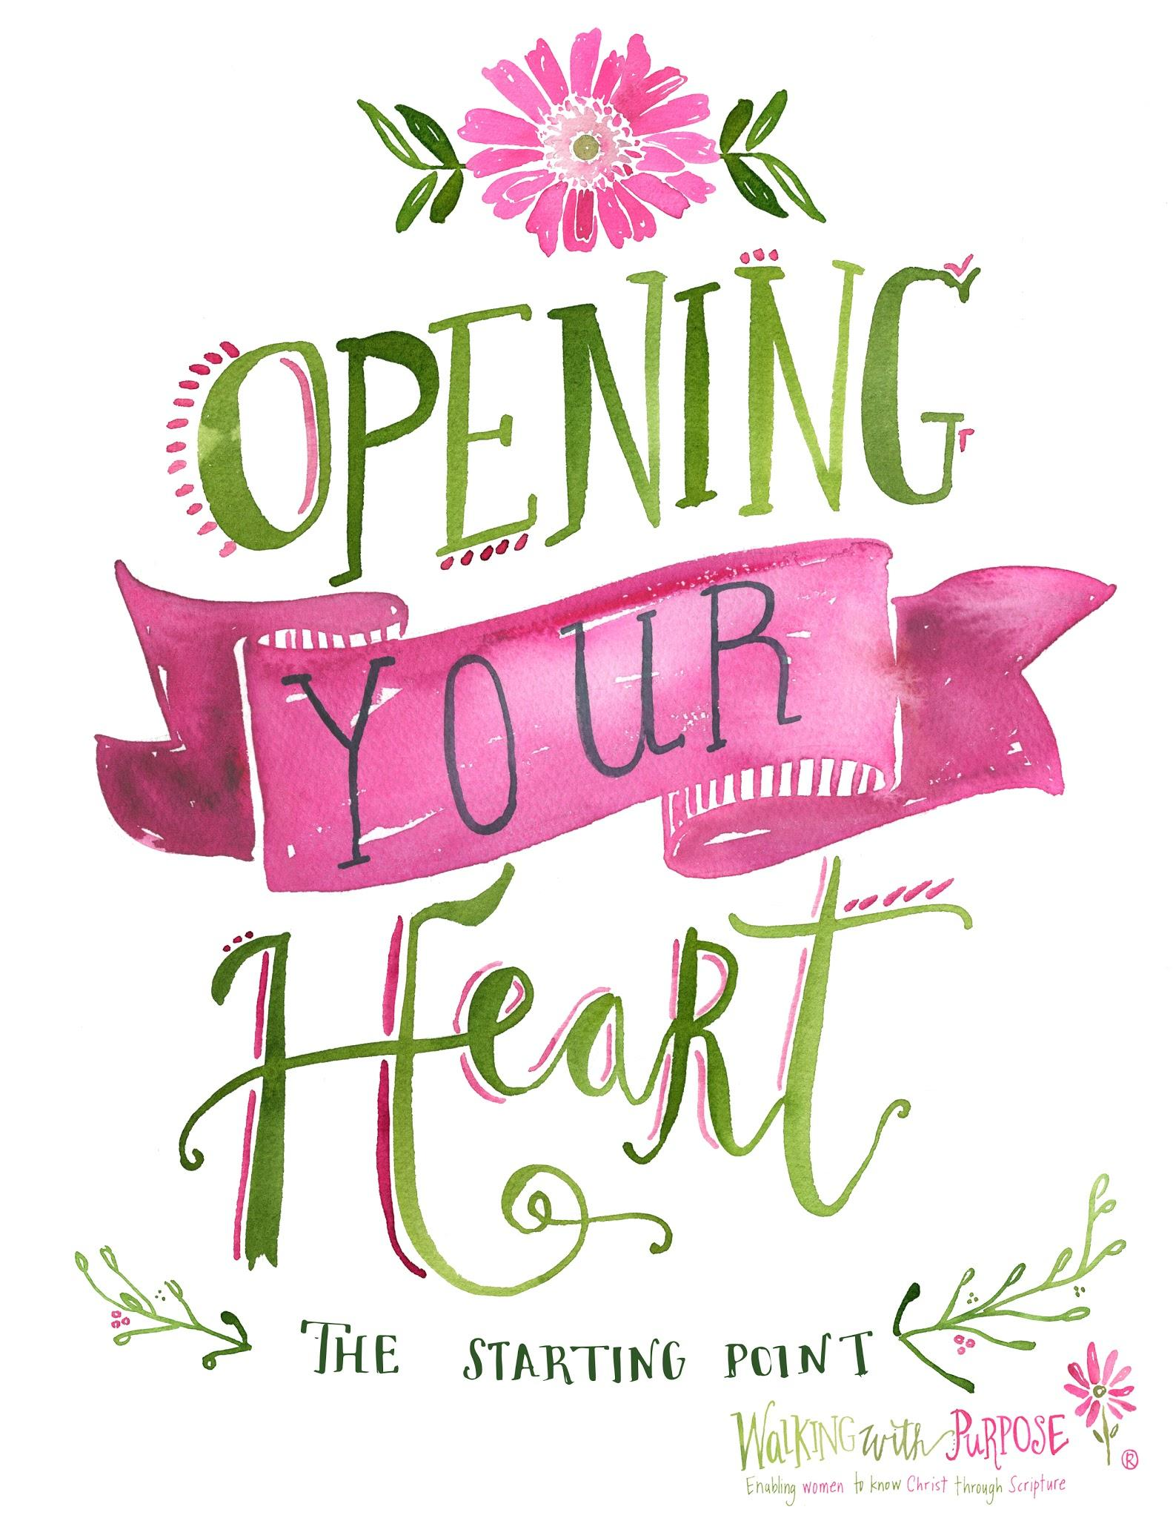
Introducing Walking with Purpose

Do you desire to grow in your Catholic faith? Do you seek connection with other women in our parish community? We invite you to consider joining Walking with Purpose this fall. Weekly group sessions start on Tuesday, October 2nd (morning session) and Thursday October 4th (evening session). Opening Your Heart, the foundational study, is designed for women who are new to Walking with Purpose and is open to all women. Whether you already have any Bible study experience or not, you’re welcome to join us as we learn how the Scriptures apply to our everyday lives.

Join us on Tuesday mornings or Thursday evenings in Holy Spirit School, meeting rooms 1 and 2, and see the parish calendar for upcoming dates.

Want to know more about the program? Contact Dawn Beutner (703 978 1096, thebeutners@cox.net) or visit Walking with Purpose online [www.walkingwithpurpose.com] for more information. We hope to see you!

