March for LIFE!
Thursday, January 22, 2015
9a.m.-4:30p.m.
The bus will be available on a first come first serve basis, so get this form in ASAP! Please return this form, with payment, no later than Sunday, January 18th.

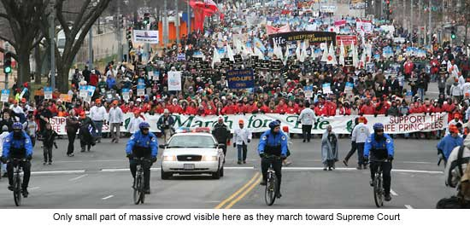
We will be attending the annual March for Life in DC again this year and we’ll be taking a bus from Holy Spirit! Let’s see if we can fill a whole bus with teens again this year! Below is our schedule for the day and what you need to bring.

Schedule:
9:00a.m. We will meet in the school cafeteria for a hot breakfast and poster making. Cost: $5 for Breakfast.
10:00a.m. There will be a special Mass just for the Pro-Life cause in the church. We will sit together and pray for an end to abortion! (Father has given us a special dispensation to eat before the Mass)
10:30a.m. We will board the bus and head to the National Mall for the March!
4:30p.m. We plan to be back by 4:30p.m. but please note that this all depends on traffic. We could be a little earlier or a little later, but this has been our return time for the last couple of years. I will have the teens call/text you when we are on our way back!
What to Bring:
- Appropriate Clothing: We will be outside for the entire march and this event goes on rain, snow or shine. Please be sure to check the weather the night before and dress accordingly. Warm coats, hats, gloves and good walking shoes are a must. Bring a small back pack and pack an umbrella/rain jacket/poncho in case of rain or snow, hand warmers etc.
- Bagged Lunch and snacks: We will be providing breakfast but please bring a lunch, snacks and water for while we’re out there.
-------------------------------------------------------------------------------------------------------------------------------
(Please turn this bottom half and the $5 in NLT January 18th)
€ Yes, my youth has permission the attend The March for Life event as described above.
€ Yes, I have a Holy Spirit Registration Form on file. If not, please go to our website www.holyspiritchurch.us to download a form or e-mail us: youthministry@holyspiritchurch.us
€ Yes, I can be a chaperone for this event!

Parent’s Signature:___________________________________ Date:_____________________
Youth’s Name: _________________________________________________________________
Best Phone number to reach a parent at during this event: _____________________________
Please circle the Breakfast Sandwich you would like:
Egg and Cheese Sausage, Egg and Cheese Bacon, Egg and Cheese

