St. Mary of Sorrows and Holy Spirit Church
Georgetown Homeless Ministry
Thursday, Nov 19, 2015 3:30p.m.-7:30p.m.
Please turn this form into Nick Jacobson (SMOS) or Kate Kelly (HS) by Nov 17th.

When: Thursday, Nov 19th 3:30-7:30p.m.

What: We will head into Georgetown and walk up and down M Street looking for homeless men and women to bring to dinner. Around 6:30 we will all reconvene at Chipotle and have dinner together before heading back to Woodson.

Who: This event is open to all teens grades 9-12. Although we will be leaving from Woodosn, you do not need to b a Woodson student ot attend!

Transportation: We will depart from and return to Woodson High School. Transportation will be provided. Please meet in front of the high school's main entrance.

What to bring: Money to buy dinner for someone else and yourself ($15)

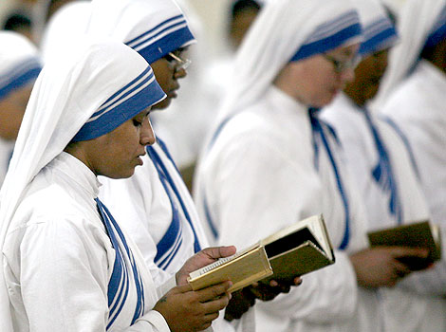
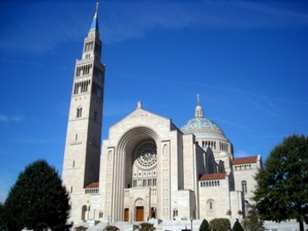
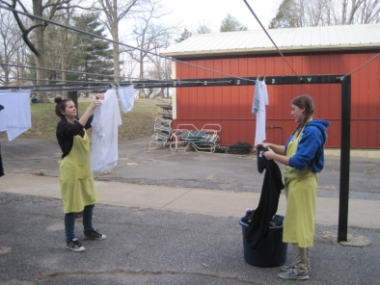
Questions?
Call Nick (SMOS): (410) 259-9753
Call Kate (HS): (703) 268-0460

-------------------------------------------------------------------------------------------------------------------------------
Cut here – save top portion for your information.

____ Yes! My teen(s) ______________________________________________________ has my permission to attend the Georgetown Homeless Minsitry as described above.
____ I would love to help drive/chaperone this event (we need drivers)!
____ I have a Registration/Liability form on file in the Youth office of (circle one):

St. Mary of Sorrows Catholic Church

Holy Spirit Catholic Church

Parent’s Signature:____________________________________________________________
Best Phone number to reach you at during this event:______________________________

