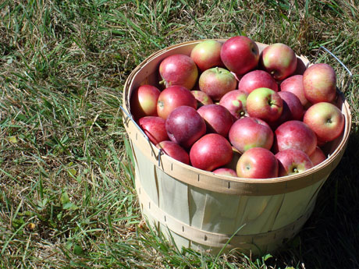
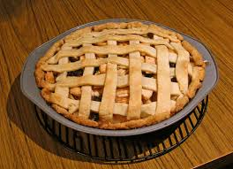
Great Apple Adventure

What better way to enjoy the fall weather than to head to a local apple orchard to
pick apples? I can smell the fresh apple pies already . . . YES, we will return to
Holy Spirit to bake apple pies and tarts! Some for the residents at the Missionaries of
Charity Gift of Peace Home in D.C. and some for you and your family.

Saturday, October 1, 2016 1:00pm – 9:00pm

Cost: $ 15

(includes a peck of apples - enough to make pies and tarts for home and

Donation and some apples to bring home! AND pizza for dinner)

Dress for the weather – we will go rain or shine. Bring a bag of apple pie
baking equipment to include a pie pan, a peeler, and a small knife. Label everything!

- Turn form and payment in to Youth Office by Wednesday, September 28.
- We must have a 2016 Youth Group registration and signed Code of Conduct on file for any youth wishing to participate prior to the trip. They are available on the web site.
- Questions? Contact Lambie Renner at 703-425-8778, ext 2 or MSYouthMinistry@holyspiritchurch.us

Cut here – save top portion for your information.
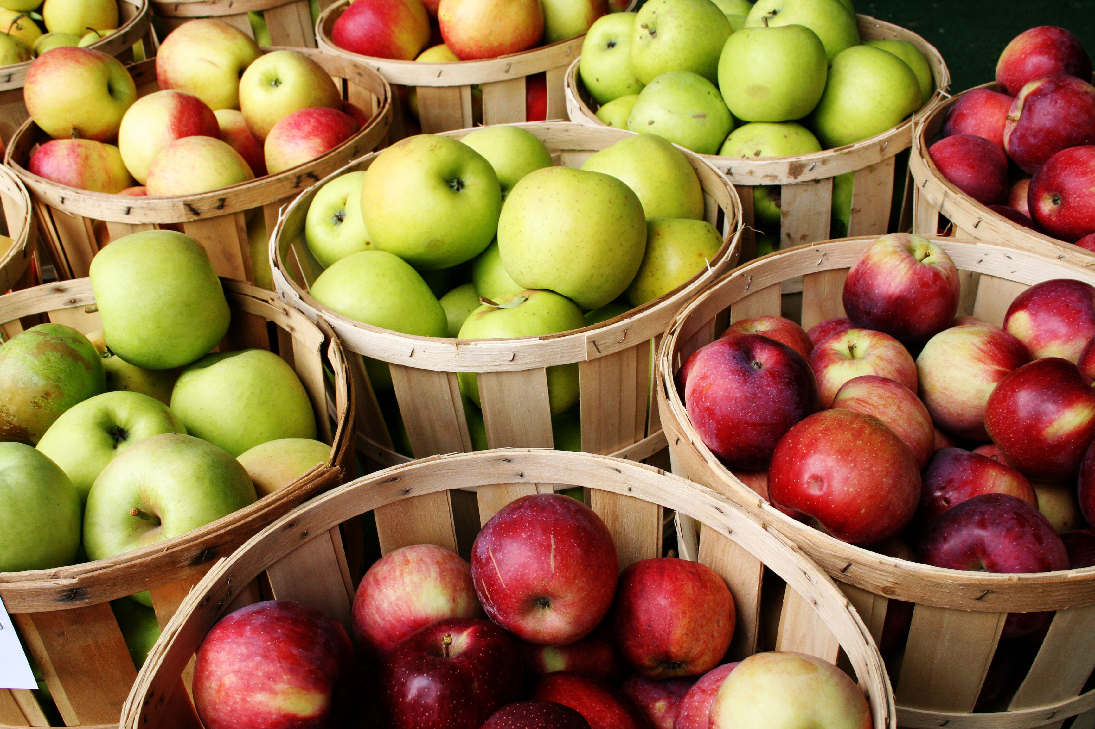
Great Apple Adventure

_____ Yes! My youth has my permission to attend the adventure on Saturday,
October 1, 2016 from 1:00pm – 9:00pm
home
Youth’s Name: _________________________________Phone:__________________________

Attached is: $15.00 I would love to chaperone. I will go to www.signupgenius.com
to sign up today. Chaperones must be Child Safety compliant (we can make that happen) and preferably drive a 7+ passenger vehicle. Chaperones are asked to pay.

Cell
Parent’s Signature:_______________________________ Phone:_______________________

I am a registered middle school youth group member (I filled out the form at holyspiritchurch.us/youth earlier this year or just now and understand it is good for all youth group meetings and events for the entire year!)

