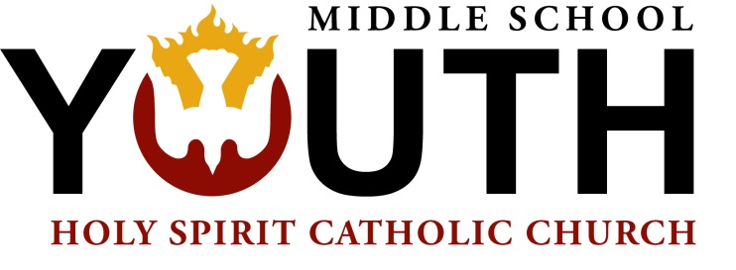

8800 Braddock Road
Annandale, VA 22003
holyspiritchurch.us

August 26, 2016

To whom it may concern,

This letter serves to confirm that ________________________ participated in the Holy Spirit “Boot Camp for Aspiring Saints” program from July 18 - 22, 2016. During this time, they performed Corporal and Spiritual Works of Mercy to include: Feeding the Hungry, Visiting the Sick, Praying for the Dead and more. The days were filled with charitable works providing community service in the true spirit of the Catholic faith.

The following number of hours count toward community service (travel time excluded):

_____ Monday: 5
_____ Tuesday: 5
_____ Wednesday: 7
_____ Thursday: 7
_____ Friday: 5

______________________ participated in the days checked above for a total of _________ hours.

If you need any additional information, please contact me, Renee “Lambie” Renner at 703-425-8778 ext. 2, or msyouthministry@holyspiritchurch.us

Kind Regards,

Lambie

Lambie Renner
Coordinator of Middle School Youth Ministry
Holy Spirit Catholic Church
703-425-8778 ext 2
msyouthministry@holyspiritchurch.us

